Game Lab 3

Please save all relevant files to your own folder.

Introduction
In the previous labs we learned how to move the tanks around the screen. One major flaw of the basic implementation was that if the player went off the screen the tank was lost. In this lab we will build a screen that will stop the tank from going off the screen or alternatively if the player goes of one side will appear on the opposite side.

Objectives
After completing this lab you should have:
- Either the tanks should be prevented from going off-screen or the tank should reappear on the opposite side of the screen.

Lets Begin by looking at preventing the tank from going off the screen:

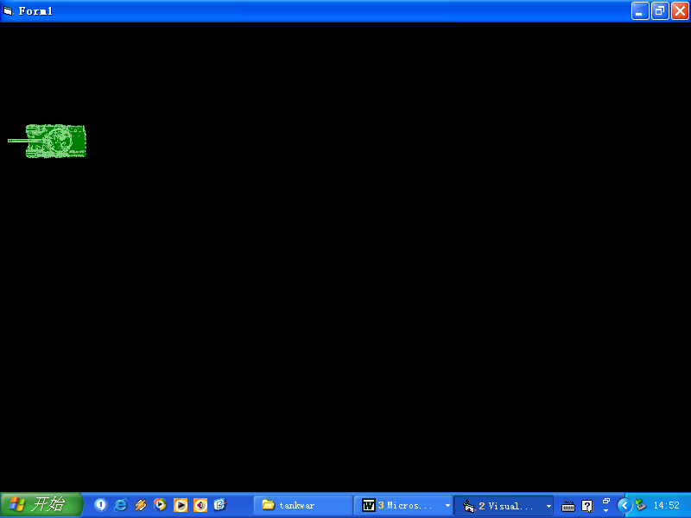

The code for making the tanks move is as for previous labs.

public void OnKeyDown(object sender, KeyEventArgs e)
{

if(e.KeyCode.ToString()=="A")
{
// ….. Code from previous lab
// add onto this event the following

DetectWall()

}

Note that a new statement within this subroutine calls a new function.

public void DetectWall()
{

if (pictureBox1.Left <= 0)
pictureBox1.Left = pictureBox1.Left + 20;
pictureBox1.Refresh();
if (pictureBox1.Left >= (this.Width - pictureBox1.Width))
pictureBox1.Left = pictureBox1.Left - 50;
pictureBox1.Refresh();

if (pictureBox1.Top <= 0)
pictureBox1.Top = pictureBox1.Top + 20;
pictureBox1.Refresh();

if (pictureBox1.Top >= this.Height - pictureBox1.Height)
pictureBox1.Top = pictureBox1.Top - 50;
pictureBox1.Refresh();
}

From going off the left hand side

if (pictureBox1.Left <= 0)
pictureBox1.Left= pictureBox1.Left + 20;
When the left position pictureBox1 reaches the 0 position of the screen i.e. the left edge of the screen then we set the left position of the image to the ‘original position + 20’ therefore preventing it from going over the left edge.

From going off the right hand side we need to stop it at the point not of the left side but of the left side + image width.

if (pictureBox1.Left >= (this.Width - pictureBox1.Width))
pictureBox1.Left = pictureBox1.Left - 50;

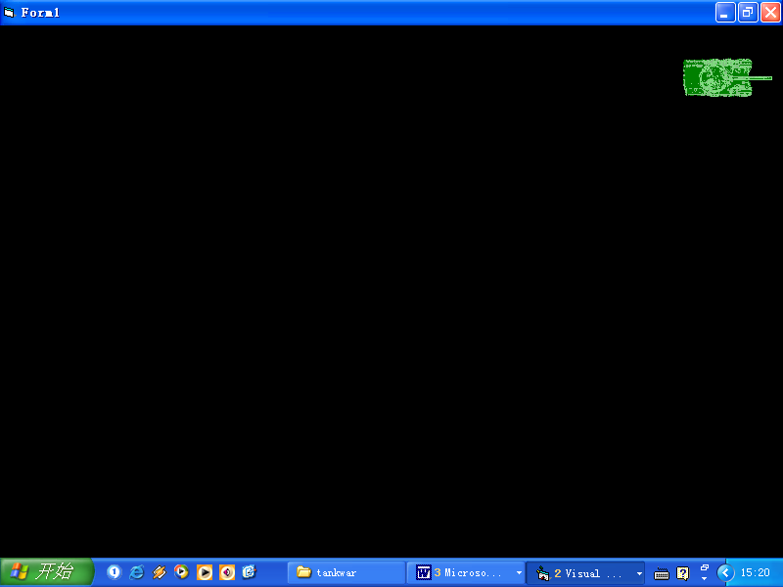
Image1.left
Image1.left + image1.width

From Going Off the Top

if (pictureBox1.Top <= 0)
pictureBox1.Top = pictureBox1.Top + 20;

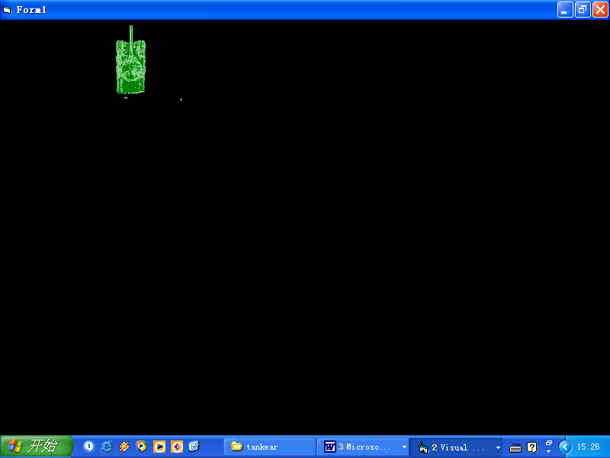
The code for preventing the tank from going off the top of the screen.

From going off the bottom

if (pictureBox1.Top >= this.Height - pictureBox1.Height)
pictureBox1.Top = pictureBox1.Top - 50;

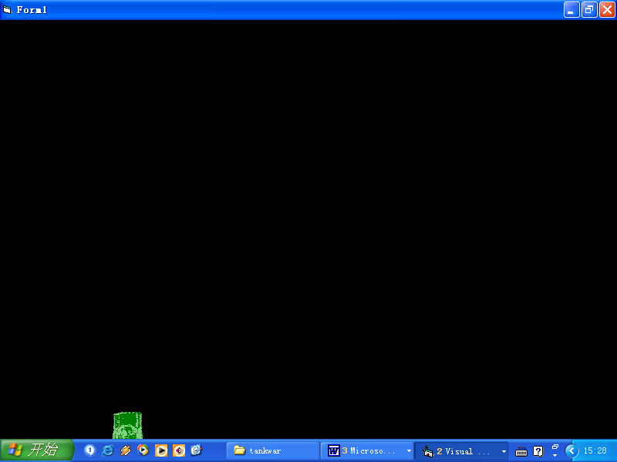
This takes into account the height of the image in the calculation to prevent the tank from going offscreen.
Image1.top
Image1.top + image1.height
Exercises: 1. Write the code for the other tank so that both tanks will be prevented from going off-screen.
2. Write code so that if the tank goes off one side it will appear on the other.

If the tank goes off the screen then being it on the opposite side.

private void timer1_Tick(object sender, System.EventArgs e)
{
switch (directiontank1)
{
….

}
OffscreenOnscreen();
}

Example code for OffscreenOnscreen

if (pictureBox1.Left + pictureBox1.Width <= 0){

pictureBox1.Left = this.Width - 1;
pictureBox1.Refresh();}

if (pictureBox1.Left >= this.Width ) {
pictureBox1.Left = 0 - pictureBox1.Width;
pictureBox1.Refresh();}

if (pictureBox1.Top <= 0 - pictureBox1.Height) {
pictureBox1.Top = this.Height-1;
pictureBox1.Refresh();}

if (pictureBox1.Top >= this.Height) {
pictureBox1.Top = 0 - pictureBox1.Height;

